**Implementation Details**

In this project most of the implementation part belongs to java so there is no things from outside of java.

As an important information we will use **java awt and swing library** to make our graphical user interface.

**Some swing GUI examples**

Login Form(It is a sample):

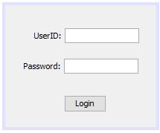

Guard add screen(It is a sample):

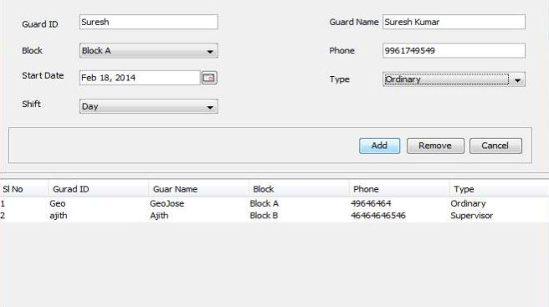

**SOFTWARE REQUIREMENTS**

|  |  |
| --- | --- |
| **Java SE Version** | Java 13 and above |
| **IDE** | NetBeans, Eclipse and IntelliJ IDEA |